**Math 120  
1.3 More on Functions and Their Graphs**

# Objectives:

1. Identify intervals on which a function increases, decreases or is constant.
2. Use graphs to locate relative maxima or minima.
3. Understand and use piecewise functions.

# Topic #1: Increasing, Decreasing, and Constant Intervals of Functions

A graph of a function tells where a function increases (rises), decreases (falls), or is constant (neither rise nor fall). Consider the intervals of the functions:

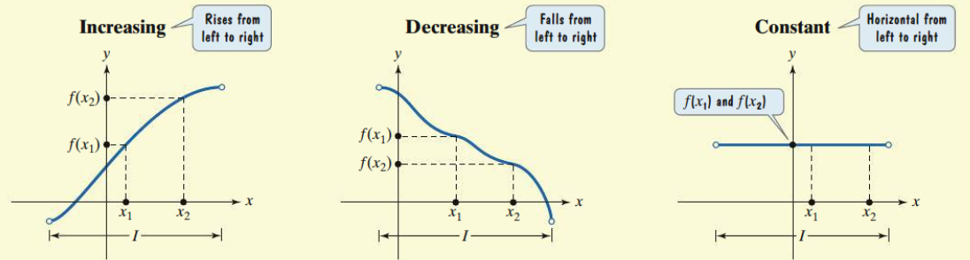

The first function is **_____________**on the interval since for all on the interval.

The second function is **______________** on the interval since for all on the interval.

The third function is **________________** on the interval since for all on the interval.

*Example #1* –

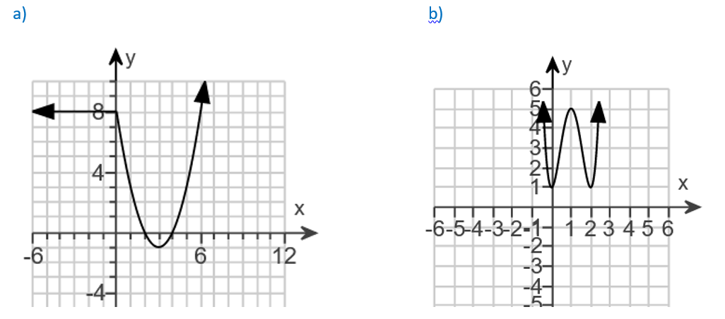Determine the Intervals where the Function is Increasing, Decreasing, or is Constant. 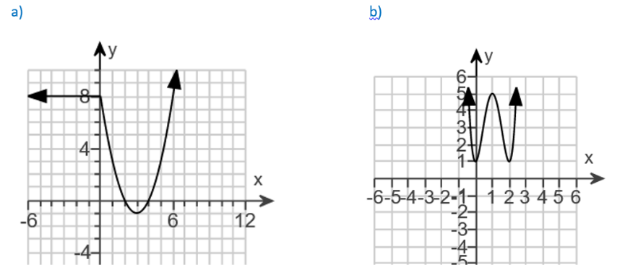 a) Looking left to right along the x-axis and using the y-axis to see how the function responds; the function starts constant, decreases, then increases. We use the ***x-values*** to write the intervals:

b) Looking left to right along the x-axis and using the y-axis to see how the function responds; the function starts decreasing, increases, decreases again, then increases again.

*YOU TRY #1:*

Determine the Intervals where the Function is Increasing, Decreasing, or is Constant.

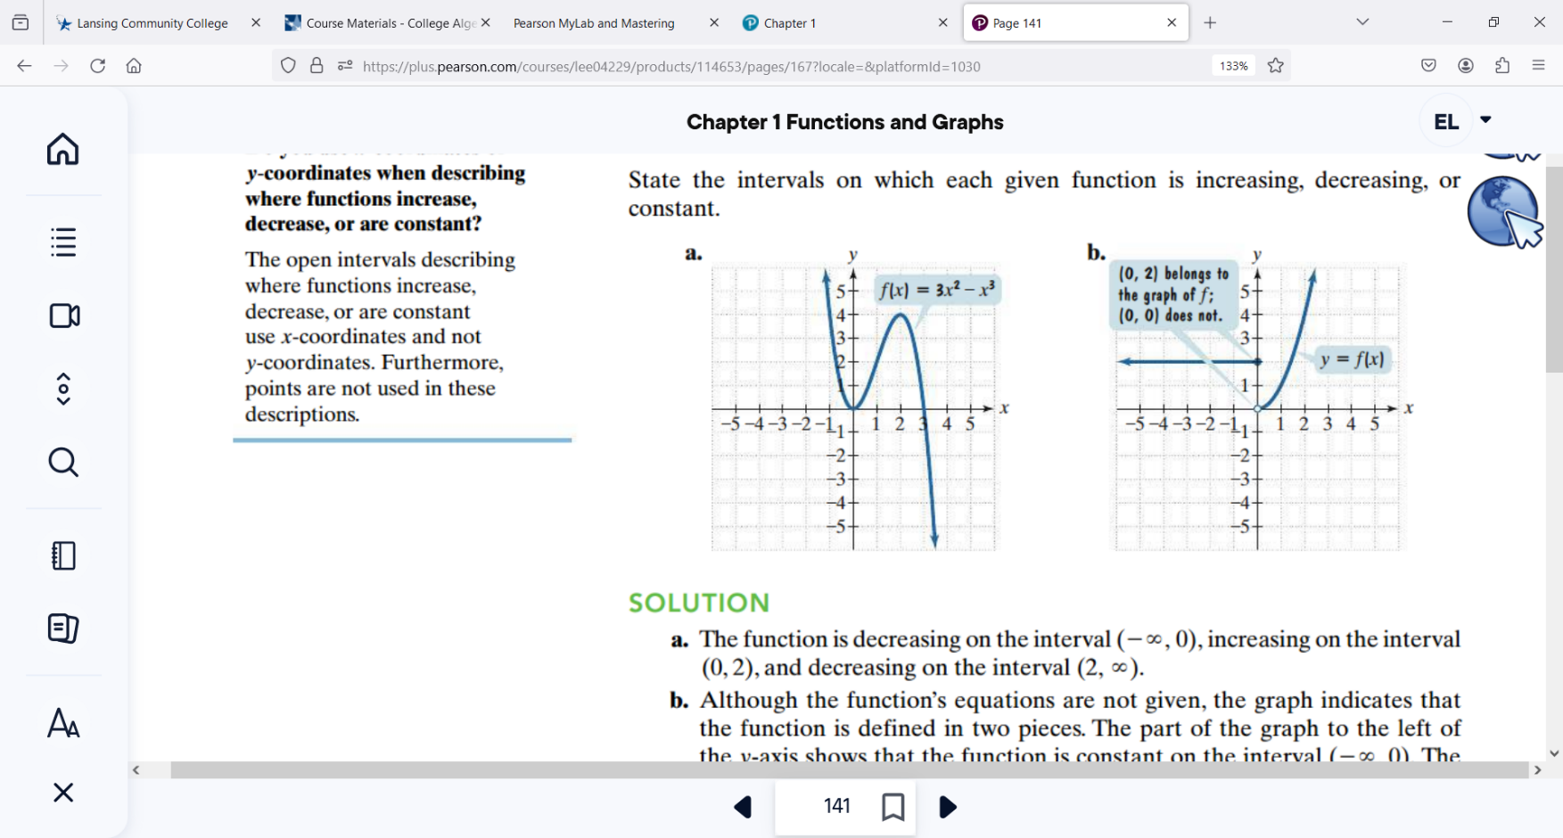

# Topic #2: Relative Maxima and Minima of Functions

A graph of a function also tells us where the function has peaks and valleys, which are more formally called **maxima** and **minima**. Consider the function:

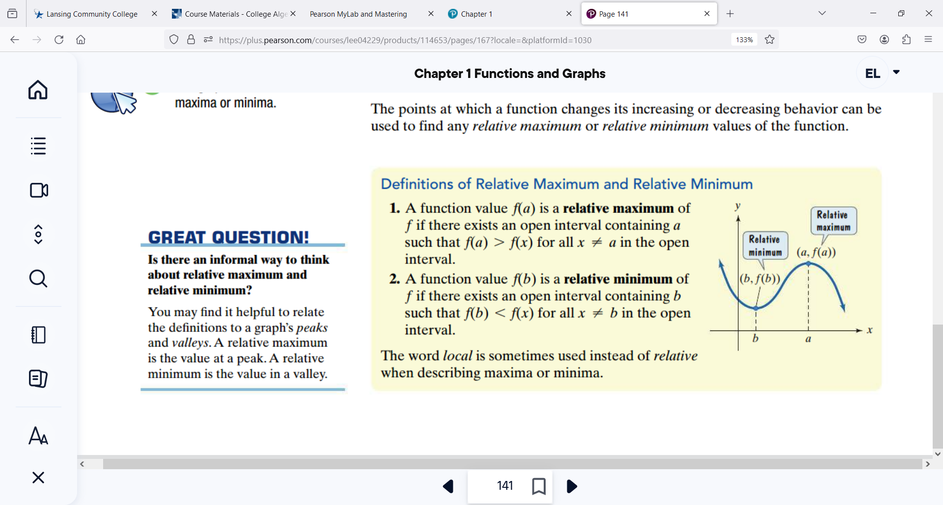

Looking left to right, we see a “valley” on the y-axis when ; this tells us the function has a relative minimum at . We then see a “peak” at ; this tells us the function has a relative maximum at . Notice that the graph changes directions at both points of interest.

*Example #1* – Find the Maxima/Minima for the Function and State the Values

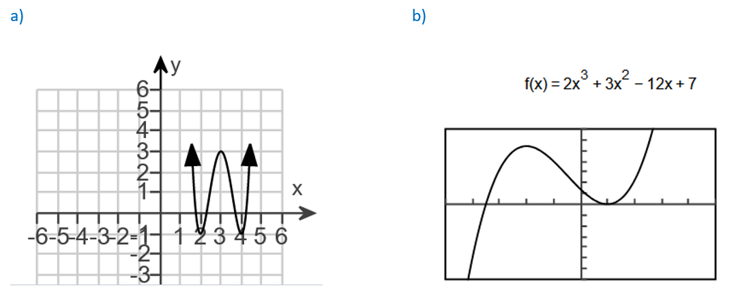a) The function changes directions 4 times, which tells us there are 3 extrema. The function decreases, increases, decreases again, and increases again.

The extrema are minima at and a maximum at

When the minimum value is at .

When what is the maximum value?

When x=4 what is the minimum value?

b) The function changes directions 3 times, which tells us there are 2 extrema. The function increases, decreases, and increases again. The extrema are a maximum at and a minimum at . To find the associated -values, we can plug in the values into the equation (the scale of the y-axis is counting by 5).

When the maximum value is at

When the minimum value is at

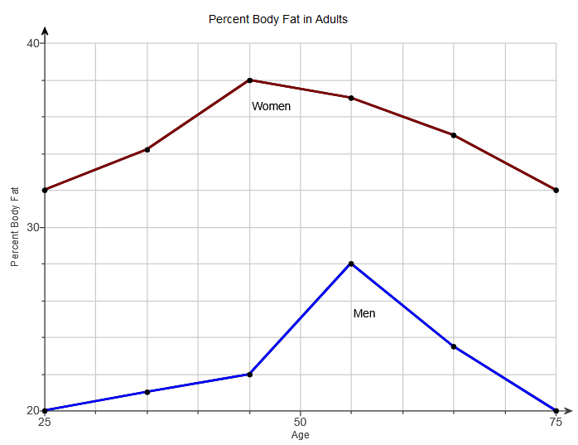

[-5,5,1] by [-35,35,5]

*Example #2* – Application

The graph shows the percent body fat of adult women and men over time (in years).

Let x be:

Let be:

a) State the domain and range for the graph of the function for women. Interpret the meaning.

b) On what interval(s) does body fat increase for men? On what interval(s) does it decrease?

c) For what age does the percent body fat for women reach a maximum?

d) Find the change in percent body fat between 45 and 55 -year old men.

# Topic #3: Symmetry

*Symmetry*: There are 3 common symmetries that a graph of an equation may exhibit.

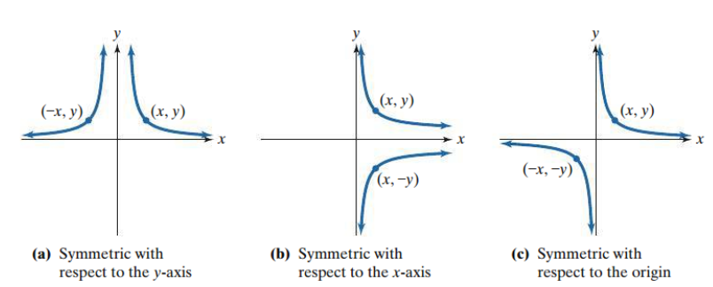

Graphs (a) and (c) represent functions; graph (b) is **not** a function ( repeats). We will focus on the symmetry of the functions.

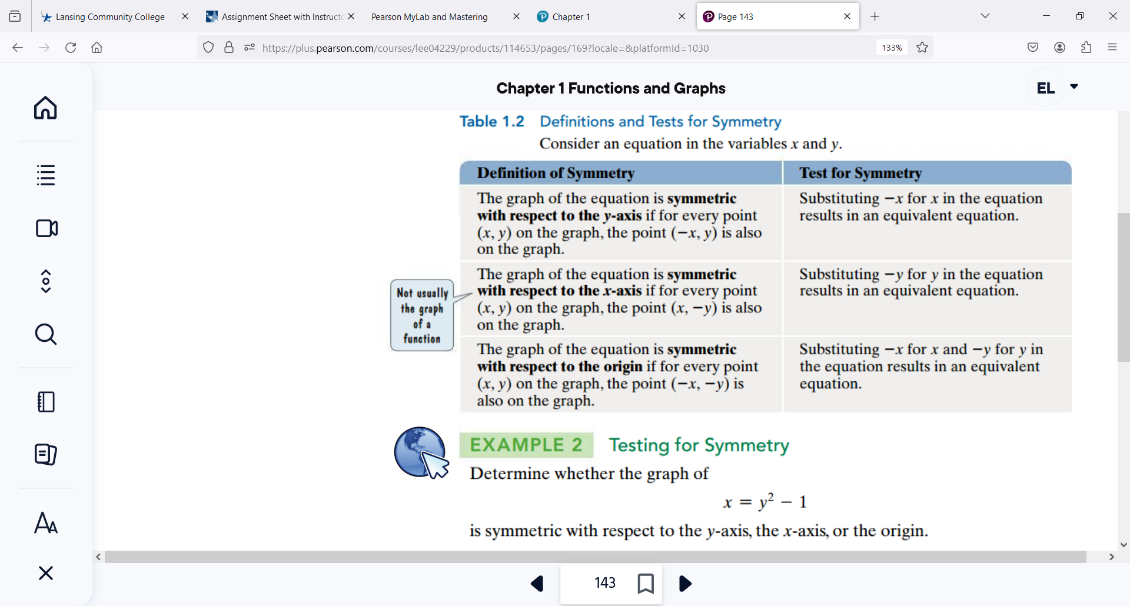

*Example #1* – Determine whether the graph of 

is symmetric to the y-axis, x-axis, or origin.

*YOU TRY #2*– Determine whether the graph of 

is symmetric to the y-axis, x-axis, or origin.

# Topic #4: Even and Odd Functions

*Even Functions*: Functions with **-axis** symmetry are EVEN. If we replace any value with its opposite value , then we get the same output. In other words, if for all in the domain, then the function is **_______________**

*Odd Functions*: Functions with **origin** symmetry are ODD. If we replace any value with its opposite value , then we get the exact opposite output. In other words, if for all in the domain, then the function is **_____________**

*Example #1* – Use the Graph of a Function to Determine if it is Even, Odd, or Neither

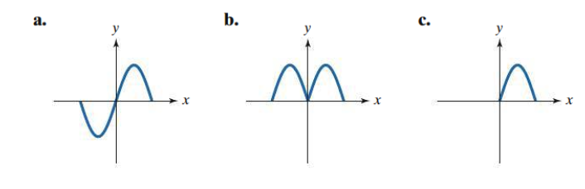

Graph a) has origin symmetry and is **ODD**. Graph b) has -axis symmetry and is **EVEN**. Graph c) does not have origin or -axis symmetry and is **________________**

*Example #2* – Use the Equation of a Function to Determine if it is Even, Odd, or Neither

a)

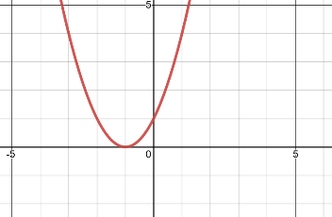Replace with and simplify:

We do not get the SAME output nor the EXACT OPPOSITE output, so the function is

**____________________**

A graph of the function confirms the result of the test:

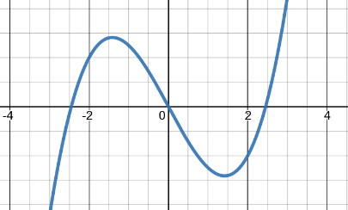b)

Replace with and simplify:

We get the EXACT OPPOSITE output for all in the domain, so the function is **______________**

A graph of the function confirms the result of the test:

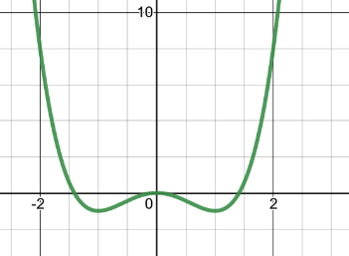c)

Replace with and simplify:

We get the SAME output for all in the domain, so the function is **__________________**

A graph of the function confirms the result of the test:

*YOU TRY #*3 - Use the Equation of a Function to Determine if it is Even, Odd, or Neither 

# Topic #5: Piecewise functions

A function that is defined by two (or more) equations over a specified domain is called a **_____________________**

1. A telephone company offers $20 per month buys 60 minutes and then additional time costs $0.40 per minute.



1. Find
2. Graph the given piecewise function on the coordinate axes provided below, and determine the domain and range of the function:

